Office of the Councillors

COUNCILLOR JEROMY FARKAS

April 16, 2019

Jeff Yang
Falun Dafa Association of Calgary
Email: calgaryfalundafa@gmail.com

Dear Mr. Yang

Re: 27th Anniversary – Falun Dafa Greeting

Falun Dafa’s message of truthfulness, compassion, and forbearance resonates strongly in Calgary and across Canada. I commend the Falun Dafa Association of Calgary for sharing this discipline with Canadians. These values are central to our democratic society.

Sincerely

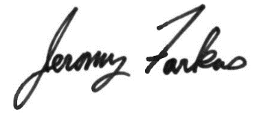

Jeromy Farkas
Councillor, Ward 11

